Name: Mushtaque Ali Khaskheli

Assignment: PF Lab 6

Sec: H

Task 1. i
Input
#include <iostream>
using namespace std;
int main ()
{
for (int i=1; i<=5; i++)
{
for (int j=1; j<=5; j++)
cout<<j<<" ";

cout<<endl;
}

return 0;
}
OUTPUT
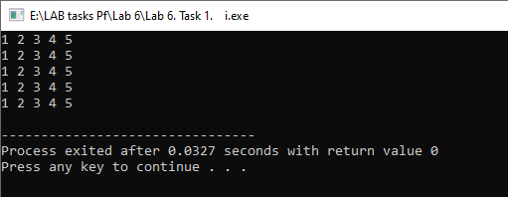
TASK 1. ii.
Input
#include <iostream>
using namespace std;
int main ()
{
for (int i=1; i<=5; i++)
{
for (int j=1; j<=5; j++)
cout<<i*j<<" ";

cout<<endl;
}

return 0;
}

OUTPUT
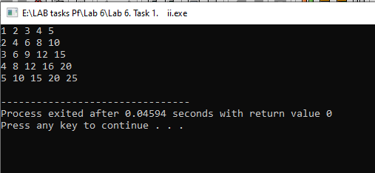

TASK 1. iii.
INPUT
#include <iostream>
using namespace std;
int main ()
{
for (int i=1; i<=5; i++)
{
for (int j=1; j<=i; j++)
cout<<j<<" ";
cout<<endl;
}
return 0;
}

OUTPUT
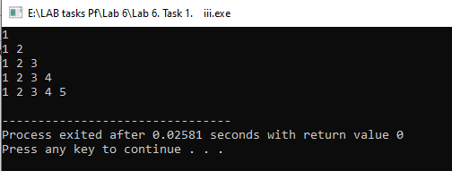
TASK 1. iv.
INPUT
#include <iostream>
using namespace std;
int main ()
{
for (int i=1; i<=5; i++)
{
for (int j=1; j<=i; j++)
cout<<" *";

cout<<endl;
}

return 0;
}
OUTPUT
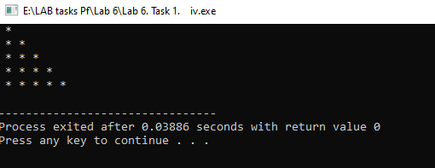

TASK 1.v.
INPUT
#include <iostream>
using namespace std;
int main ()
{
for (int i=1; i<=5; i++)
{
for (int j=i; j<=5; j++)
cout<<j<<" ";

cout<<endl;
}

return 0;
}

system("PAUSE");
return 0;
}

OUTPUT
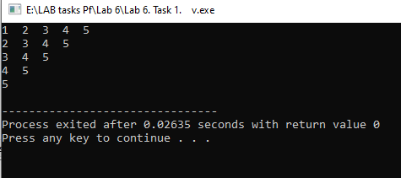

TASK 1.vi
INPUT
#include <iostream>
using namespace std;
int main ()
{
for (int i=1; i<=5; i++)
{
for (int j=i; j<=5; j++)
cout<<" *";

cout<<endl;
}

return 0;
}
OUTPUT
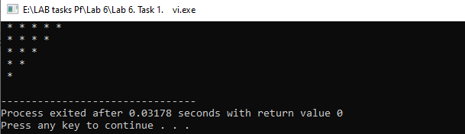

Task 1. Vii.
Input

#include <iostream>
using namespace std;
int main ()
{
for(int i=1; i<=5; i++)
{
for(int j=1; j<=i; j++)
cout<<"* ";

cout<<endl;
}
for (int i=1; i<=4; i++)
{
for(int j=i; j<=4; j++)
cout<<"* ";

cout<<endl;
}

return 0;
}
Output
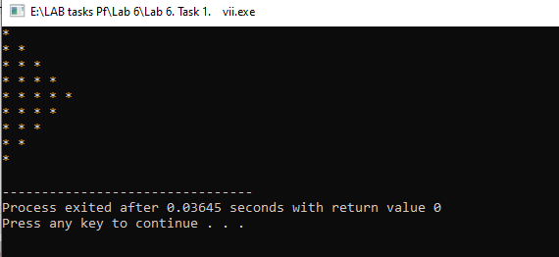
Task 1. Viii.
Input
#include <iostream>
using namespace std;
int main ()
{
for(int i=1; i<=5; i++)
{
for(int j=1; j<=i; j++)
cout<<i<<" ";

cout<<endl;
}

return 0;
}
Output
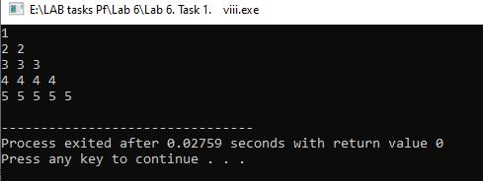

Task 2
Input
#include <iostream>
using namespace std;
int main ()
{
int No_of_students, No_of_scores, score;
double average;
cout<<"The program averages test scores. \n\n";
cout<<"\n For how many students do you have scores? ";
cin>>No_of_students;

cout<<"\n How many test scores does each student have? ";
cin>>No_of_scores;

for (int h=1; h<=No_of_students; h++)
{
double sum=0;
for(int i=1; i<=No_of_scores;i++)
{

cout<<"Enter score "<<i<<" for student "<<h<<" :";
cin>>score;
sum+=score;
}
average=sum/No_of_scores;
cout<<"\n The average score for student "<<h<<" is "<<average;
cout<<endl;
}

return 0;
}

Output
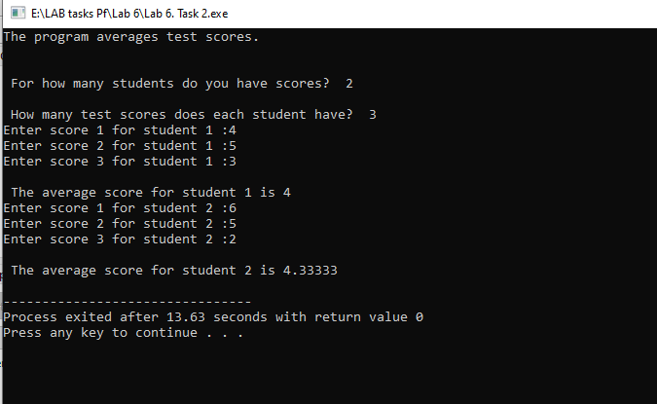

Task 3
Input
#include <iostream>
using namespace std;
int main ()
{
int range;
cout<<"Enter a range upto which you want to find tables: ";
cin>>range;

for (int i=1; i<=range; i++)
{
cout<<"table of "<<i<<endl;
for (int j=1; j<=10; j++)
{
cout<<j<<" * "<<i<<" = "<<j*i;
cout<<endl;
}
cout<<endl;

}

return 0;
}
OUTPUT
